Forecasting and Time Series Methods

Stationary Time Series Case

**Ashwita Saxena**

# Problem Statement

The saving rate is personal saving as a percentage of disposable personal income. Some economists believe shifts in this rate contribute to business fluctuations. For example, when people save more of their income they spend less for goods and services. This reduction in total demand for output may cause national production to fall and unemployment to rise.

In this case study, we analyze 100 quarterly observations of the U.S. saving rate for the years 1955~1979. The data are seasonally adjusted prior to publication by the U.S. Department of Commerce (i.e., no need to consider seasonality).

For such a data set, assume stationarity (i.e., no need to check for stationarity), build an ARMA model, perform data transformation (if needed), model identification, model selection, diagnostic checking, parameter estimation, and forecast the next two years. Write a short report summarizing your results, but **no longer than 15 pages.**

# Data

**DATA** CASE;

DO YEAR=**1955** TO **1979**;

DO QUARTER=**1** TO **4**;

DATE=YYQ(YEAR,QUARTER);

INPUT SAVING @@;ONE=**1**; OUTPUT;

END;

END;

KEEP DATE SAVING ONE; FORMAT DATE YYQ4.;

*LABEL SAVING=(PERSONAL SAVING/DISPOSABLE INCOME)*100;

CARDS;

4.9 5.2 5.7 5.7 6.2 6.7 6.9 7.1 6.6 7 6.9 6.4 6.6 6.4 7 7.3 6 6.3 4.8

5.3 5.4 4.7 4.9 4.4 5.1 5.3 6 5.9 5.9 5.6 5.3 4.5 4.7 4.6 4.3 5 5.2

6.2 5.8 6.7 5.7 6.1 7.2 6.5 6.1 6.3 6.4 7 7.6 7.2 7.5

7.8 7.2 7.5 5.6 5.7 4.9 5.1 6.2 6 6.1 7.5 7.8 8 8 8.1 7.6 7.1

6.6 5.6 5.9 6.6 6.8 7.8 7.9 8.7 7.7 7.3 6.7 7.5 6.4 9.7 7.5 7.1 6.4

6 5.7 5 4.2 5.1 5.4 5.1 5.3 5 4.8 4.7 5 5.4 4.3 3.5

;

**PROC** **PRINT**; **RUN**;

Following is a screenshot of a section of the output of the dataset

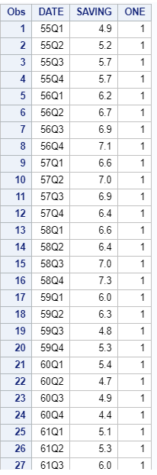

This dataset contains 100 observations.

# Identification of the Model

**PROC** **ARIMA**;

IDENTIFY VAR=SAVING;

**RUN**;

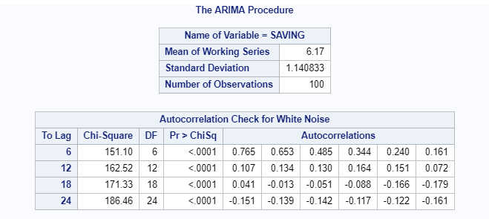

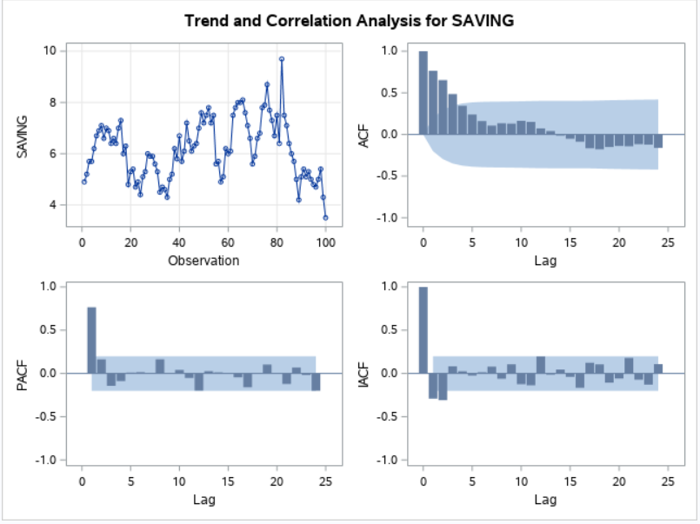

Observation

* The mean of this series is 6.17 and standard deviation is 1.14
* Autocorrelation check shows all p values are very less than 0.05 and hence significant. This means the series is not a white noise
* The time series looks stationary as the mean and variance do not look like they vary too much
* ACF appears to be exponentially decaying. The PACF plot shows that it has a cutoff at lag of 1
* The above reasons make this model an AR(1) model for sure.

# Estimation of Model Parameters

**proc** **arima**;

identify var=SAVING minic;

estimate p=**1**;

**run**;

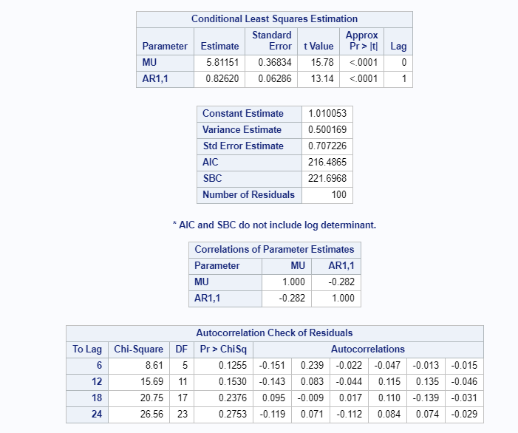

Observation:

* Conditional Least Squared Estimation method is used for parameter estimation
* Mean of the time series is 5.81 with a very small P-value and hence significant.
* Phi 1 (At lag 1) is 0.826 and is significant
* Autocorrelation check has insignificant p-values that means we fail to reject the null hypothesis that residuals follow only white noise. We need further analysis

# Residual Diagnostics

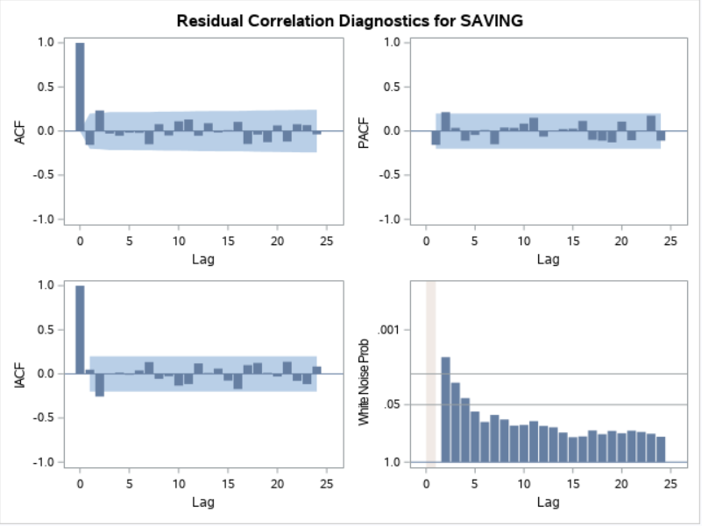

Observation

* The PACF plot of the residuals shows that at lag of 2, the PACF is slightly outside the band. Hence we should fit an MA(2) model so we can compensate for the PACF at lag 2
* The minic function (below) shows that BIC is the least for the case when AR component is 1 and MA component is 2

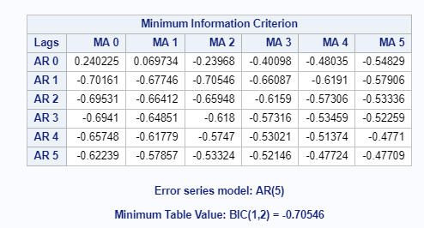

# Model modification

**proc** **arima**;

identify var=SAVING;

estimate p=**1** q=**2**;

**run**;

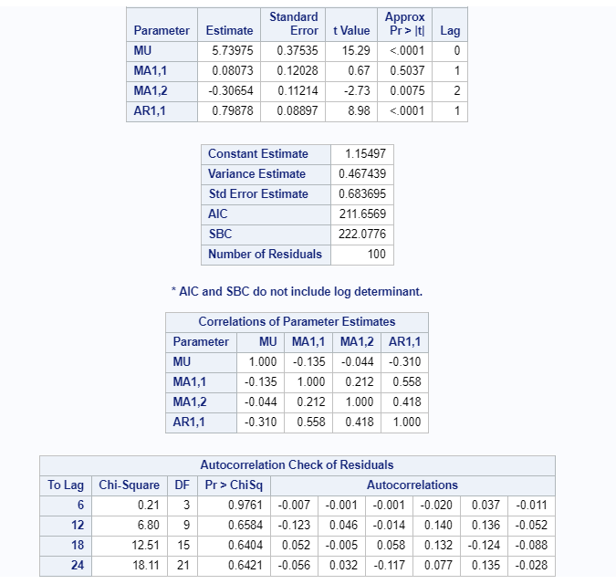

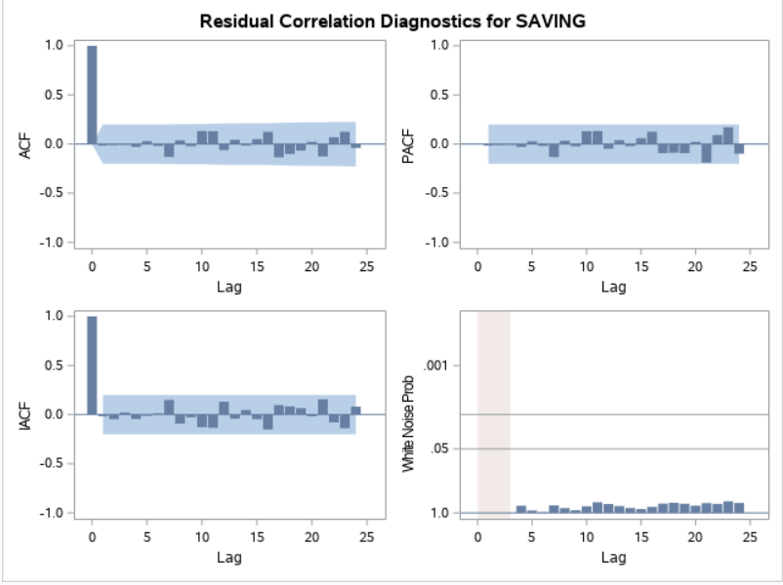

From the above table we can see that the parameter estimate for MA(1) at lag 1, is insignificant. However, for MA(2), it is significant. Hence we will get rid of MA(1) component and build our model with only MA(2)

**proc** **arima**;

identify var=SAVING;

estimate p=**1** q=(**2**);

**run**;

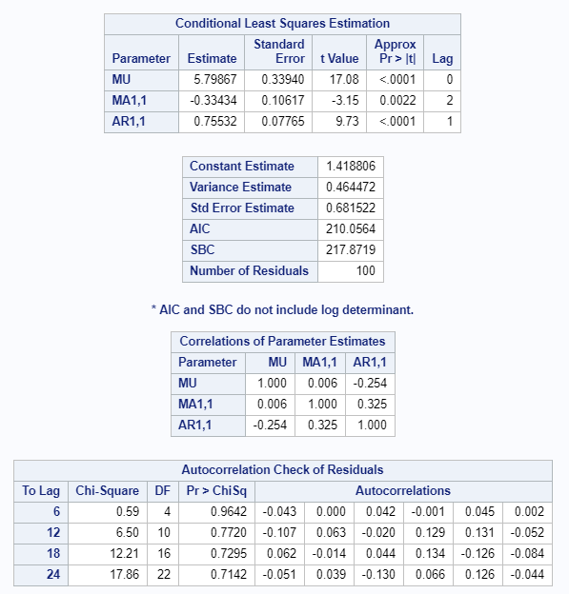

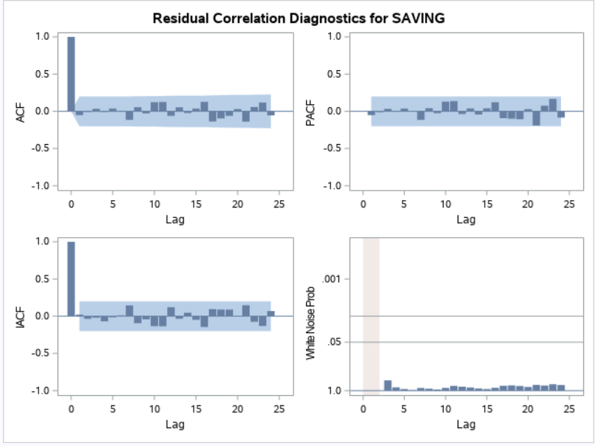

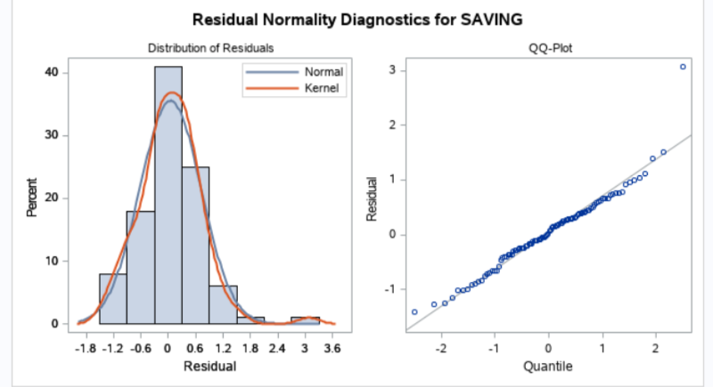

Observation

* Here we can see the estimate of MA(2) at lag 3 is significant with a value of -0.334 (theta 2).
* Mean of this time series is 5.799 and phi is1 is 0.755. Both are significant
* The residual plots show that the ACF and PACF values are inside the confidence band and hence seem to be white noise.
* Residuals follow a normal distribution

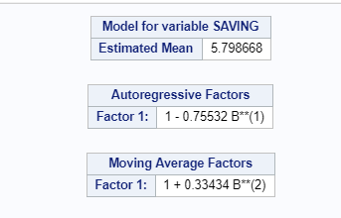

Thus our final model is ARMA(1,2) :

*(1 – 0.75532*B) (z – 5.798668) = (1 + 0.33434*B2) at*

# Forecasting for next two years

**proc** **arima**;

identify var=SAVING;

estimate p=**1** q=(**2**) method=cls;

**run**;

forecast lead=**8** out=output;

**quit**;

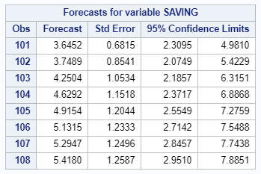

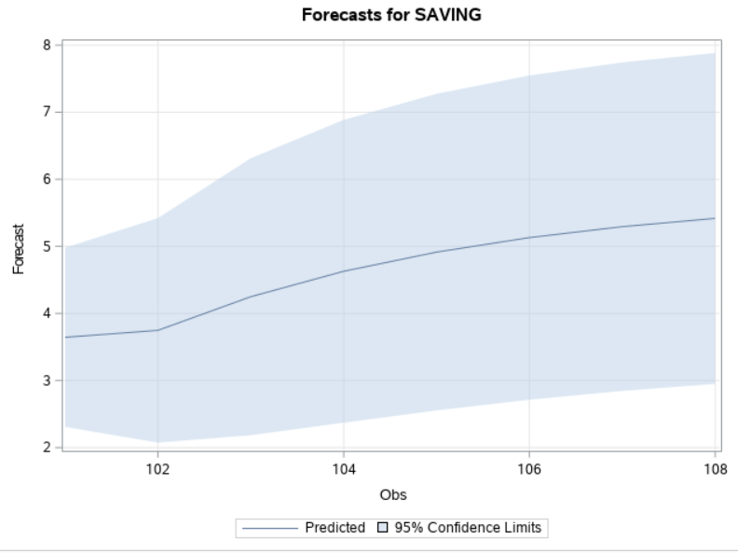

We can see that savings will increase in the next 2 years from 3.65 in 1980 Q1 to 5.42 in 1981 Q4